**ShopNest Store POWER BI Capstone Report**

**1.Identify the Rating Distribution in Shop_Nest dataset, showcasing ratings categorized as Excellent, Very good, Good, Bad, Very Bad along with corresponding orders.**

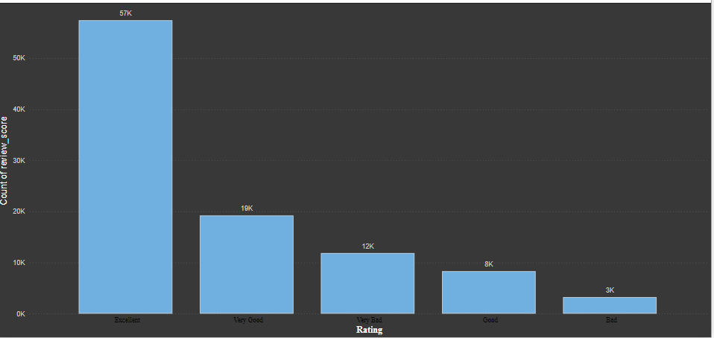

**Insights:**

• The majority of ratings fall in the "Very Good" category, with over 45,000 orders.

• "Excellent" ratings are the second most common, with about 35,000 orders.

• "Good" ratings come in third, with approximately 20,000 orders.

• There are relatively few "Bad" and "Very Bad" ratings, each with less than 5,000 orders.

• This distribution suggests that customers are generally satisfied with their SHOPNEST experiences.

**2.Top 10 Product Categories:**

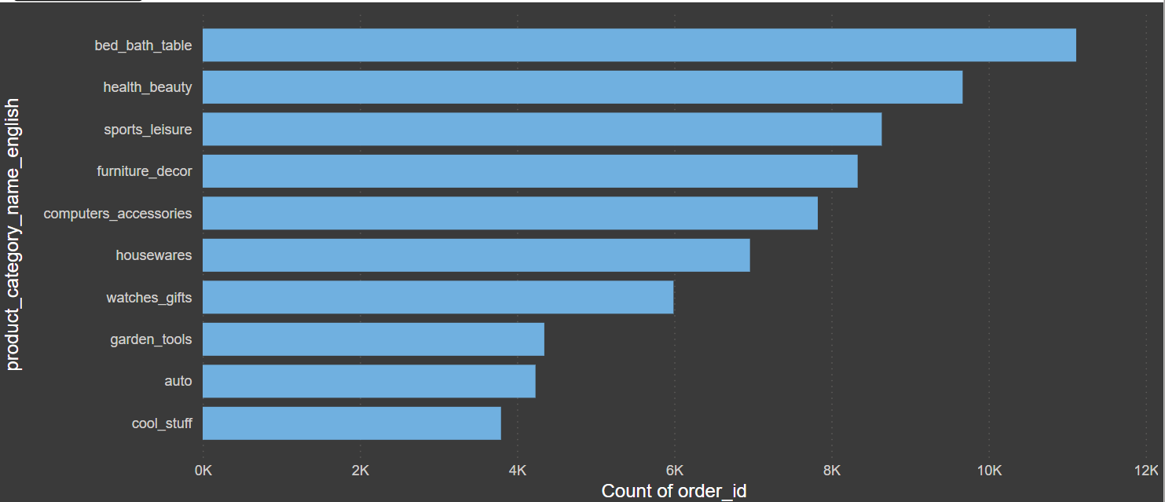

**Insights:**

• bed_bath_table" is the leading category with over 11,000 orders.

• "health_beauty" and "sports_leisure" follow closely behind.

• The top 3 categories significantly outperform the others.

• There's a gradual decrease in order numbers from the 4th to the 10th category.

• This information can help in inventory management and marketing focus.

**Bottom 18 Product Categories:**

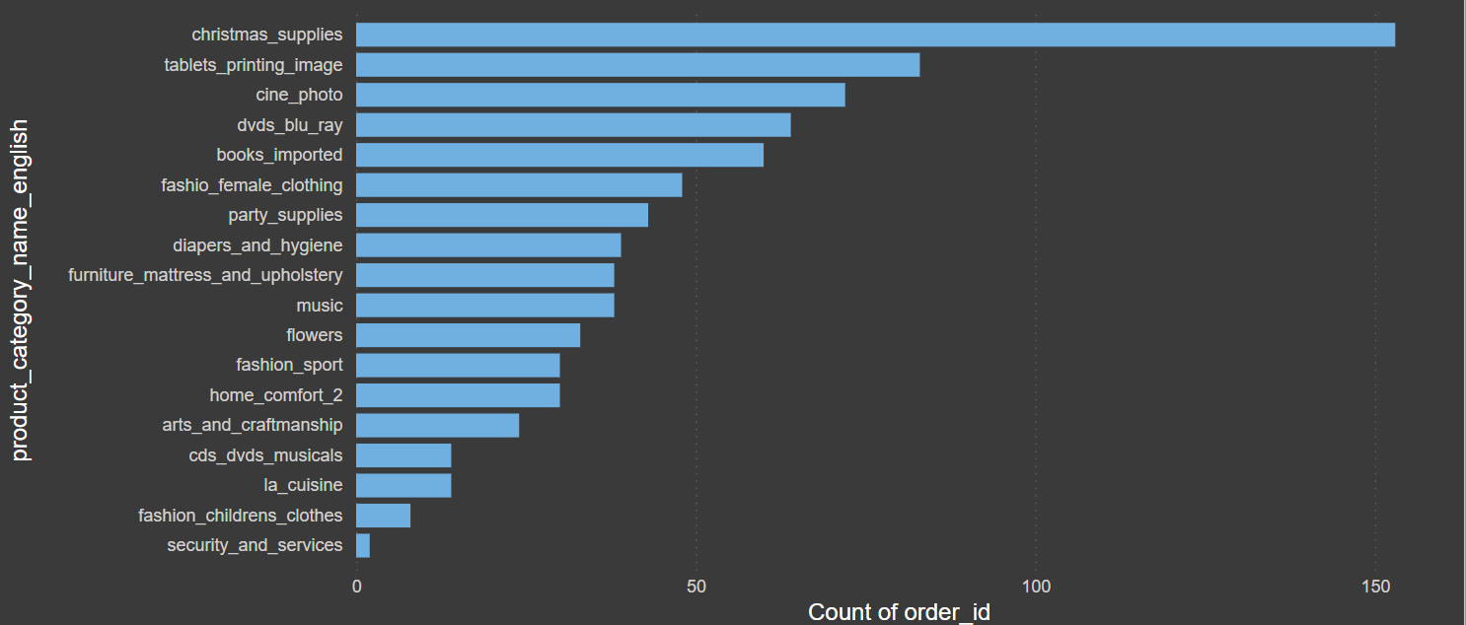

**Insights:**

• "security_and_services" is the lowest-performing category with less than 100 orders.

• Most categories in this list have fewer than 1,000 orders.

• There's a significant gap between these categories and the top performers.

• This data could be used to decide which product lines to potentially phase out or improve.

**3.List the Total No. of Active Sellers by Yearly and Monthly:**

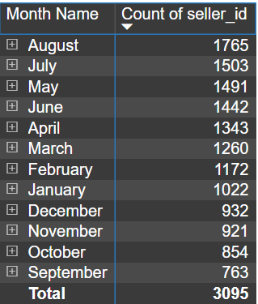

**Insights:**

• The yearly table shows a significant increase in active sellers from 2016 to 2017, and then a smaller increase to 2018.

• The monthly table shows fluctuations in active seller numbers throughout the year.

• August appears to have the highest number of active sellers, while January has the lowest.

• This data could be useful for understanding seller engagement trends and planning seller support initiatives.

**4.Which Payment Methods are most used by shopNest Customers:**

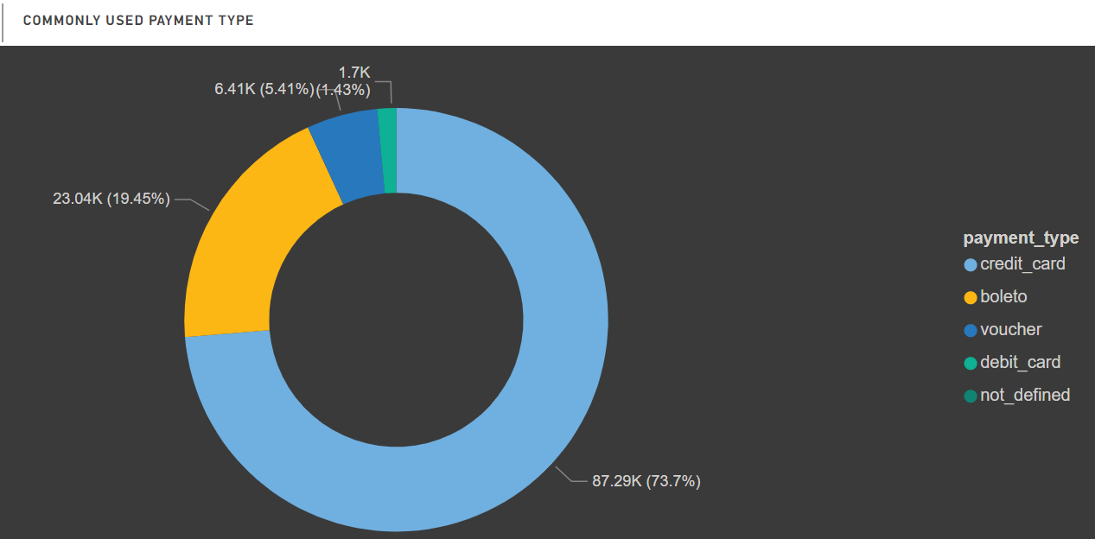

**Insights:**

This pie chart illustrates the distribution of payment methods.

• Credit card is overwhelmingly the most popular payment method, accounting for about 75% of transactions.

• Boleto is the second most common, used in roughly 19% of transactions.

• Voucher and debit card are used much less frequently, each accounting for about 3% of transactions.

• This information can guide payment processing strategies and potentially inform decisions about payment method promotions or partnerships.

**5.Identify the Product Category wise Profit Margin.**

**Hint:** **(payment value- price +frieght value)/payment value*100 round to two decimals**

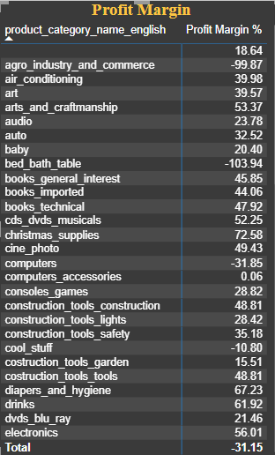

**Insights:**

* Profit margins are crucial indicators of a company's financial health and operational efficiency. They show how much profit is generated from each dollar of revenue.
* Sometimes businesses operate on low margins but make up for it with high sales volumes. Others may have lower sales but higher margins per item.
* In highly competitive markets, profit margins tend to be slimmer as companies compete on price to attract customers.
* Improving profit margins often involves careful cost management, including optimizing supply chains, reducing waste, and increasing operational efficiency.
* The ability to maintain or increase prices without losing customers is key to preserving or improving profit margins.

**6.Determine the Monthly payment made by customers using Credit Card.**

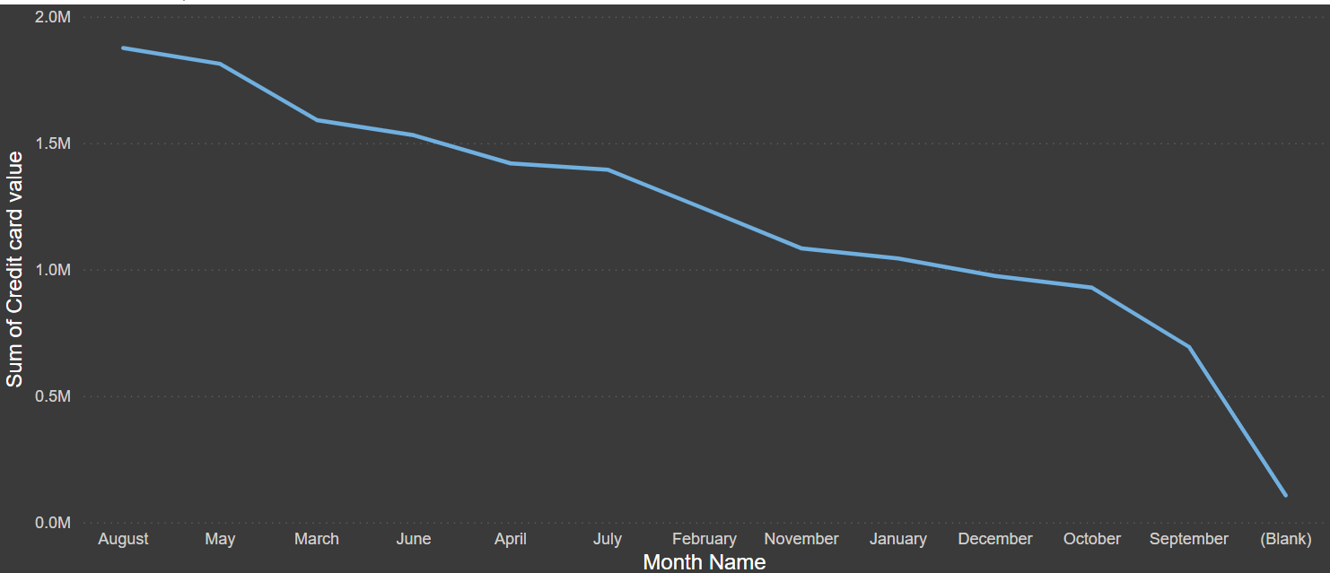

**Insights:**

* Overall trend: There's a clear downward trend in credit card payments over time.
* Highest value: The highest credit card payment sum was in August, at around 2.0M.
* Significant drops: There are some notable drops, particularly between July and February, and again between October and September.
* Recent decline: The most recent months (September and October) show a sharp decline, possibly indicating a recent change in customer behavior or company policy.

**7.Identify Sellers categorized by City, excluding cities starting with ‘S’ and ‘B’.**

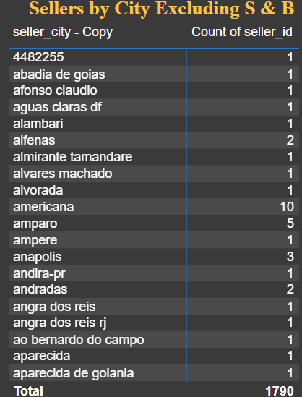

**Insights:**

* Total sellers: The table shows a total of 1,790 sellers across all listed cities.
* Curitiba has the highest number of sellers with 127.
* Most cities listed have only 1 or 2 sellers, indicating a dispersed distribution of sellers across many locations.
* Exclusions: As requested, the list excludes cities starting with 'S' and 'B', which might have affected the total count and distribution of sellers.
* This data provides a snapshot of seller distribution across various Brazilian cities, showing a spread of e-commerce activity across diverse locations, with a few cities having a slightly higher concentration of sellers.

**8.Create a dynamic visual that compares the no.of delayed orders to the no of orders received earlier for each month. Utilize the drill through the cross report feature to provide to Detailed visual analysis of Late and On-time Deliveries.**

**Insights:**

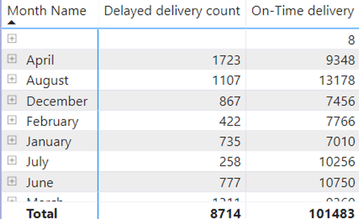

* In our report, we found that April, March, and August have the most late deliveries each month. This suggests there might be problems or difficulties happening during these times.
* In March and August, there are many instances of deliveries being late. However, there are also quite a few occasions when deliveries are on time. This indicates a fairly balanced performance despite facing challenges.
* In December and May, we tend to see more delays in deliveries compared to the rest of the year. This could be because more people are shopping during holidays or for special events.